Further Lending Poc
SoW
- Template (User Story 1)
  - Design template
  - Upload / Management of template
  - https://sahomeloans.atlassian.net/wiki/spaces/CSH3/pages/95161405/Application+Form+-+Acceptance+Criteria+-+Income+and+Expenses
  - https://sahomeloans.atlassian.net/wiki/spaces/CSH3/pages/95134795/Application+Form+-+Acceptance+Criteria+-+Templates
- Report Generation
  - https://sahomeloans.atlassian.net/wiki/spaces/SIMS/pages/92936562/Aspose+Cloud+Service
  - Pre-populate data (User Story 2,3,4)
    - Make it like SARS form
      - Set Appearance
        - Border Color
        - Fill Color
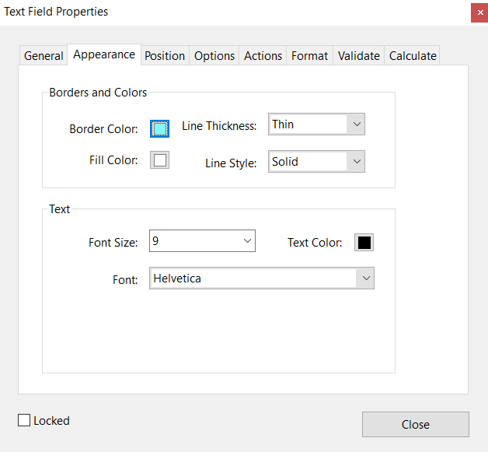
      - Set Options
        - Comb of x characters will cause it to place blocks and only allow that many items
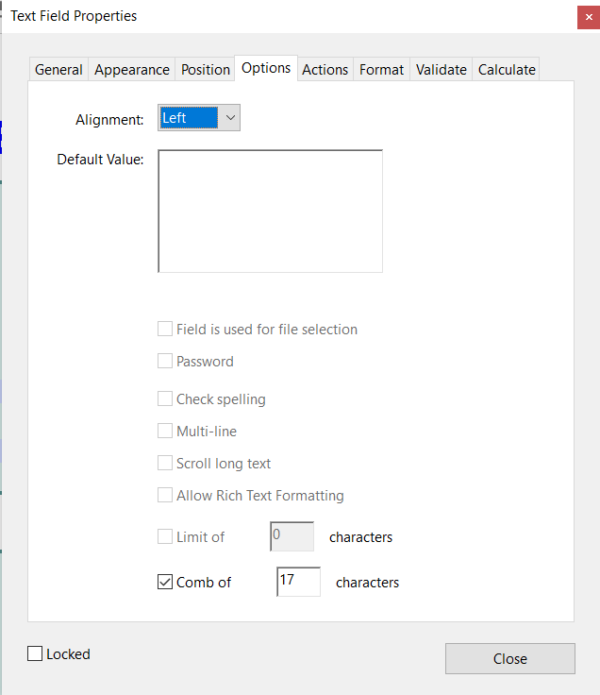
    - personal details
      - https://sahomeloans.atlassian.net/wiki/spaces/CSH3/pages/95136472/Acceptance+Criteria+-+Application+Forms+-+Personal+Details
    - contact details
      - https://sahomeloans.atlassian.net/wiki/spaces/CSH3/pages/95136688/Application+Form+-+Acceptance+Criteria+-+Contact+Details
    - address details
      - https://sahomeloans.atlassian.net/wiki/spaces/CSH3/pages/95137237/Application+Form+-+Acceptance+Criteria+-+Address+Details
  - In-line editing
    - Make pdf have editable regions (User Story 5)
    - Lock down pre-populated regions
      - https://sahomeloans.atlassian.net/wiki/spaces/CSH3/pages/95069281/2+-+Further+Lending+Application+Forms
    - Income and Expense Calculations (User Story 6)
      - Editable fields must be to nearest Rand (no cents)
      - Total fields must automatically calculate
      - https://sahomeloans.atlassian.net/wiki/spaces/CSH3/pages/95161405/Application+Form+-+Acceptance+Criteria+-+Income+and+Expenses
  - Document security (User Story 7)
    - Encryption of document using applicants ID number
    - https://sahomeloans.atlassian.net/wiki/spaces/CSH3/pages/138084363/4+-+Halo+Correspondence+-+Sensitive+Information
  - Embed QR code for tracing into form
    - Write into PDF
    - Read from PDF
- Swagger for Nancy Services to demo
  - I believe we should push into web service territory to facilitate demos via swagger
- Migrate Standalone PoC into code?
Issues
- It has been raised in the tech forum to ensure that BarCodes can be created and embedded into the document. And that they can be read too!
  - https://github.com/codebude/QRCoder
    - Read
  - https://products.aspose.cloud/barcodeRead
    - $99 / month included in current subscription
Risk
- Environment setup
- Ensure seams are in place for key areas of PoC to facilitate main code integration
  - Template management
  - Document management
Action Items
- Ensure SAHL has Acrobat Pro DC for form creation
- Advise SAHL to purchase Aspose.Pdf for the work
  - Can use 30 day trial to move forward
- Sense check production workflow
  - Ensure seams in PoC

